Appendix A

Biographies of the speakers

Rachel Campbell – Senior Policy Officer & Head of Regional Programme, British Property Federation (BPF)

- Rachel is a Senior Policy Officer at the BPF, which represents the interests of organisations who own and invest in real estate in the UK. This includes working with BPF members, Government and other stakeholders to influence and develop policy related to infrastructure and regeneration. Since joining the BPF in 2014, Rachel has implemented and now leads on a regional programme of work for the organisation in order to inform central Government as to the impact of national policy on different places, as well as engaging with local and combined authorities and BPF members across the UK to ensure the sector is able to deliver regional growth and sustainable development.

Will Colthorpe - Argent and Chair of the BPF’s Development Committee

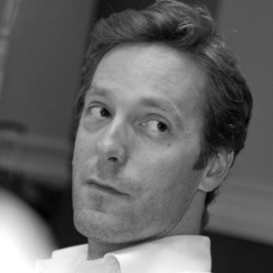
- Will joined Argent in 2006 and works on Argent’s mixed use schemes. He also leads on commercial developments and leasing at King’s Cross where he is responsible for development totalling a gross value of £1.5bn. Will is also a specialist in refurbishment and re-use of historic buildings and structures. At a corporate level, Will is involved in internal learning and development as well as strategic initiatives. He is also involved in new opportunities, commercial review, and structuring.

- Will read Architecture at Sheffield University, and has a Masters in Planning and Development. Before joining Argent Will worked in valuation, town planning and architecture. He is chair of the British Property Federation’s Development Committee, sits on CoreNet’s UK Executive Board and is a member of the Royal Institution of Chartered Surveyors.

Pete Gladwell, Head of Public Sector Partnerships, L&G Real Assets

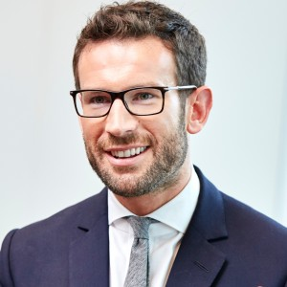
- Pete Gladwell joined Legal & General in August 2007, with responsibility for the design and development of new funds and overseeing relationships with pension funds, investment consultants, and insurance clients. In 2013, Pete was appointed Head of Public Sector Partnerships, to lead L&G's direct investments into partnerships with RIO/UKTI, Registered Providers, Universities, NHS Trusts, Local Authorities, and central government. These investments now total over £1.7bn.

- Pete was formally a Senior Analyst in DTZ Research and enjoyed an erstwhile life as a youth worker for seven years in the Oxfordshire area. Member of Oxford University, holding a post-graduate MA, as well as an initial degree in Computation, he also holds the Investment Management Certificate. Pete is also a Trustee for the Young Foundation, which works to create a more equal and just society through social innovation.

